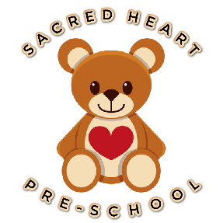
Sacred Heart Pre-school
Heys Street
Thornton-Cleveleys
FY54HL
Tel: 07835711921
EY 318019

(19) Nappy changing (EYFS – 3.61)
Policy statement
No child is excluded from participating in our setting who may not yet be toilet trained and who may still be wearing nappies or equivalent. We work with parents towards toilet training, unless there are medical or other developmental reasons why this may not be appropriate at the time.
We provide nappy changing facilities and exercise good hygiene practices in order to accommodate children who are not yet toilet trained.
We see toilet training as a self-care skill that children have the opportunity to learn with the full support and non-judgemental concern of adults.
Procedures
- Key persons have a list of personalised changing times for the children in their care who are in nappies or ‘pull-ups’.
- Children from two years should wear pull ups, or other types of trainer pants, as soon as they are comfortable with this and their parents agree.
- Key persons typically undertake changing children in their key groups; but all staff are familiar to all children so can undertake changing of others key children when needed.
- Changing areas are warm with safe areas to lay children.
- Each child has their own backpack with their nappies or pull ups and changing wipes inside including a change of clothes.
- Gloves and aprons are put on by staff before changing starts and the areas are prepared.
- All staff are familiar with the hygiene procedures and carry these out when changing nappies.
- In addition, key persons ensure that nappy changing is relaxed and a time to promote independence in young children.
- Children are encouraged to take an interest in using the toilet; they may just want to sit on it and talk to a friend who is also using the toilet.
- Children are encouraged to wash their hands and have soap and disposable paper towels to hand. They should be allowed time for some play as they explore the water and the soap.
- Anti-bacterial hand wash liquid or soap should not be used for young children; young skin is quite delicate and anti-bacterial products kill off certain good bacteria that children need to develop their own natural resistance to infection.
- Key persons are gentle when changing; they avoid pulling faces and making negative comments about ‘nappy contents’.
- Key persons do not make inappropriate comments about children’s genitals when changing their nappies.
- Older children access the toilet when they have the need to and are encouraged to be independent.
- Nappies and pull ups are disposed of hygienically. Any soiled nappies or pull ups are bagged and put in the nappy bin. Trainer pants and ordinary pants that have been wet or soiled are rinsed and bagged for the parent to take home.
- We have a ‘duty of care’ towards children’s personal needs. If children are left in wet or soiled nappies/pull ups in the setting this may constitute neglect and will be a disciplinary matter.

_________________________________________________________________________

Policy adopted/implemented by SACRED HEART PRE-SCHOOL in:
August 2023
Date to be reviewed:
August 2024
Signed on behalf of management team:
Chelsea Porter (Deputy) – 24/8/23

