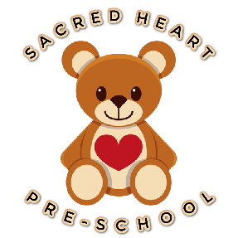
Sacred Heart Pre-school
Heys Street
Thornton-Cleveleys
FY54HL
Tel: 07835711921
EY 318019

(29) No Smoking/Vaping (EYFS – 3.57)
Policy statement
We comply with health and safety regulations and the Safeguarding and Welfare Requirements of the Early Years Foundation Stage in making our setting a no-smoking environment - both indoors and outdoors.
Procedures
- All staff, parents and volunteers are made aware of our No-smoking/vaping Policy.
- The No-smoking/vaping Policy is stated in our information for parents.
- We actively encourage no-smoking,/vaping by providing information for parents and staff about where to get help to stop smoking if they are seeking this information.
- Staff who smoke/vape do not do so during working hours, unless on a break and off the premises.
- Staff who smoke/vape during their break make every effort to reduce the effect of the odour and lingering effects of passive smoking for children and colleagues.
_________________________________________________________________________

Policy adopted/implemented by SACRED HEART PRE-SCHOOL in:
August 2023
Date to be reviewed:
August 2024
Signed on behalf of management team:
Chelsea Porter (Deputy) – 24/8/23

